Process Abstraction & RAPTOR Subcharts and Procedures
By Dr. Wayne Brown
Introduction
When developing an algorithm that will be executed by a computer, we write the steps in terms of what a computer can accomplish. These steps tend to be rather simple instructions because a computer has a limited number of instructions it understands. This makes computer algorithms that accomplish complex tasks long and intricate. Hence they can be hard to understand, difficult to get correct, and tough to modify.

So what can we do to deal with this complexity? Well, it would help if the computer executing the algorithm was “smarter” and could perform complex operations in a single step. Well conceptually the computer can! We accomplish this by grouping a set of statements that accomplish a specific task into a "process" which has a unique name. Then, whenever we need that specific task performed, we "call" the process and conceptually it executes as a single step in our algorithm. We have already seen this with the routines in RAPTORGraph. For example, the Draw_Circle procedure will draw a circle if we call it. Inside the Draw_Circle routine, it does many individual steps to actually create the circle, but we don’t need to worry about the details. All we care about is that it does what it is supposed to do. The details have been “abstracted” away and that is just fine by us; we have other things to worry about. We call this “process abstraction” because we are defining a new process and abstracting away the details behind its name.

As mentioned earlier, process abstraction is a wonderful aid in dealing with complexity, but it can also save us a great deal of time. Consider the Draw_Circle routine again. Someone graciously wrote the individual steps which make this routine do its thing and they only had to do this once. Now all users of RAPTOR can simply call this routine to draw a circle. Had that someone not created the Draw_Circle routine, each of us would have to write all the steps to draw a circle every time we needed a circle drawn. This would surely slow us down!

The RAPTOR programming environment provides two mechanisms for implementing process abstraction: subcharts and procedures. Typically students who are new to programming find subcharts easier to create and understand. On the other hand, procedures are "enhanced" subcharts and new programmers typically find procedures more difficult to understand. Procedures allow different values to be "passed" and changed on each call to the process. These "passed" values are called parameters. You might recall that Draw_Circle is called with such parameters, as in
Draw_Circle( x, y, radius, color, filled )

Procedures make it easier to change the behavior of a process because each call to the process can send a different set of initial values.

Since subcharts are typically easier to understand, we will concentrate our studies on subcharts. However, you are welcome and encouraged to investigate procedures and to use them in place of subcharts if you are willing to tackle their added complexity.
Process Abstraction
You may have seen the commercial with the “Easy Button”. The Easy Button is a big red button which, when pressed, gets you whatever you need. You can think of this Easy Button as a kind of ultimate “process abstraction”. Hiding behind its name are all of the steps to do whatever is needed. We don’t see those steps because they are abstracted away behind the process name, but we don’t care. We just care that it does what it does.

Unfortunately, the Easy Button does not really exist. So we’ll need to accomplish our own process abstraction by writing our own subcharts and/or procedures.

Let’s say that we wanted to draw a bull’s eye. RAPTOR does not include a command to draw a bull's eye, but we can use RAPTOR’s Draw_Circle routine to do this ourselves. We could build our own process that would call Draw_Circle several times -- first drawing a big filled circle and then drawing smaller and smaller ones. Each circle would have the same center but smaller and smaller radiuses. We could put all of these calls to Draw_Circle into a process called something terribly clever like “Draw_Bulls_Eye.” Then we could just call Draw_Bulls_Eye whenever we wanted a bull's eye drawn. The great advantage of this is that we never again need to worry about how Draw_Bulls_Eye does its thing.

Subcharts
The easiest way to implement Draw_Bulls_Eye in RAPTOR is to use a subchart.
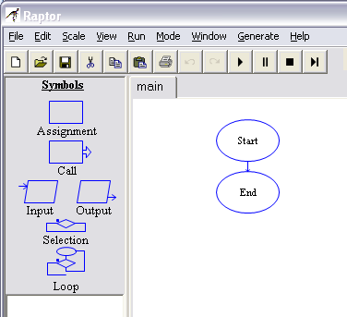
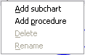
To create a subchart, position your mouse cursor over the "main" subchart tab (which is circled in red in the figure to the right) and click and hold down the RIGHT mouse button. A pop-up menu will appear, as shown to the right. (If your RAPTOR "mode" is set to "Novice," then only the "Add subchart" option will be shown in the pop-up menu. If your RAPTOR "mode" is set to "Intermediate," you will also see an "Add procedure" option.) Highlight the "Add subchart" option in the pop-up menu and release the mouse button. A new dialog box will appear that prompts you for a subchart name. All subcharts (and procedures) must have a unique name.

Each subchart that is created will have a "tab" to the right of the "main" subchart tab. The following example shows a program that has been broken into 4 subcharts: main, Initialize_screen, Draw_characters, and Animate. To edit each subchart you must click its associated tab. You can only view/edit one subchart at a time.

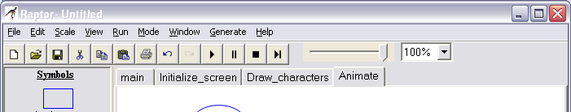

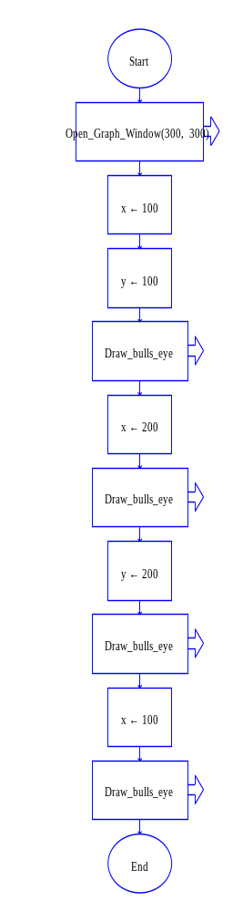
When you execute a program it will always begin at the "Start" symbol of the "main" subchart. Other subcharts are executed only when they are "called" using a call statement. The following example RAPTOR program illustrates these ideas. The "main" subchart is shown to the left. A subchart called "Draw_bulls_eye" is shown below. If you executed this program it would produce the graphics output shown on the right.

Draw_bulls_eye subchart
Execution Output
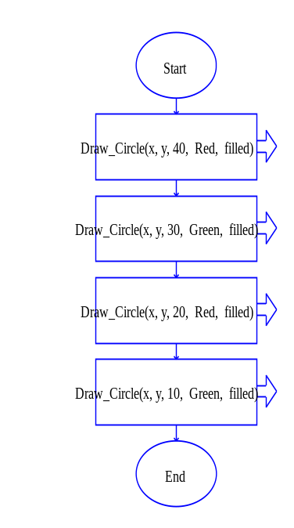
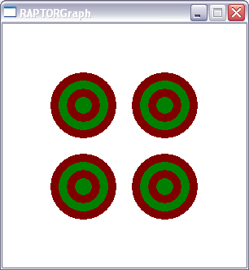

When a subchart is called, all of its statements are executed until the subchart's "End" statement is reached. Then execution continues with the statement after the subchart call. The entire program terminates when the End" statement of the "main" subchart is executed. Notice that in the example program to the left the "Draw_bulls_eye" subchart is called four times and each time the values of x and y are different. Therefore the program draws 4 bulls-eyes, each in a different location.

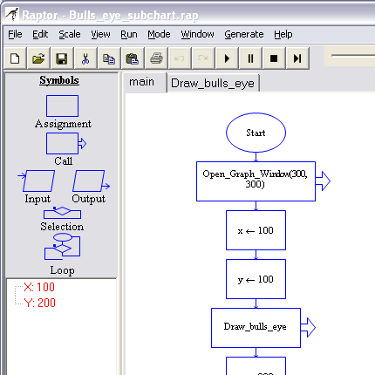
The major distinguishing feature of subcharts is that all subcharts use the same variables. A variable can be modified in one subchart and then used in other subcharts. You can visually see this fact in the example figure to the right. Notice that there is only one variable called X and one variable called Y listed in the variable area of RAPTOR (which is circled in red).

In conclusion, subcharts can be used to divide a program into distinct (and hopefully related) sets of statements. This allows for a complex program to be solved by a set of smaller, less complex sub-programs. Subcharts also have the additional advantage of eliminating duplicate code in a program. This can be seen in the bulls-eye program where the code to draw a bulls-eye only had to be written once, not 4 separate times. If you use subcharts appropriately, your programs will typically be shorter, easier to develop, and easier to debug than an equivalent program without subcharts.
Procedures
As you just saw, using subcharts definitely made the program smaller and easier to understand. However, it was cumbersome to use separate assignment symbols to keep resetting X and Y before calling Draw_Bulls_Eye. It sure would be nice if we could just pass in the values for X and Y like we do for Draw_Circle.

Well the good news is that we can, but instead of using a subchart, we’ll use a “procedure”. A procedure is similar to a subchart in that it is a separate set of instructions that can be executed by making a "call" to the procedure. However, a procedure is more flexible because we can provide it with different initial values each time it is called. This is done using parameters. A procedure parameter is a variable in the procedure that receives an initial value when the procedure is called, and/or changes the value of variable in the calling sub-program when the procedure terminates. Parameters are defined when a procedure is created and are included with a procedure name when a procedure is called. To illustrate these ideas, please study the following example RAPTOR program that produces the same bulls-eye output as the previous subchart example program. As you study this example, carefully note the following:
- Notice the text, "(in x, in y)" in the Start statement of the Draw_bulls_eye procedure. This means the procedure has two input parameters, X and Y, which are given initial values when the procedure is called.
- Notice that each call to the Draw_bulls_eye procedure in the "main" subchart now contains a list of values in parentheses, e.g., (100,200). The first value defines the initial value of X, while the second value defines the initial value for Y. The order of parameters is important. The order of the values in the call must always match the order of the parameters in the procedure definition.
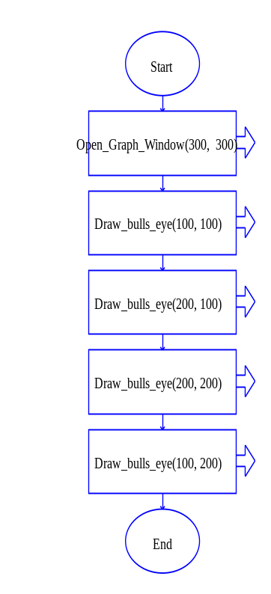
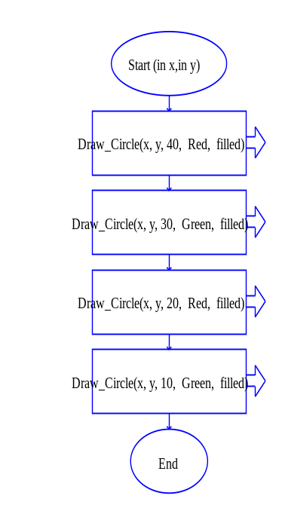
"main" subchart
Draw_bulls_eye procedure
Execution Output

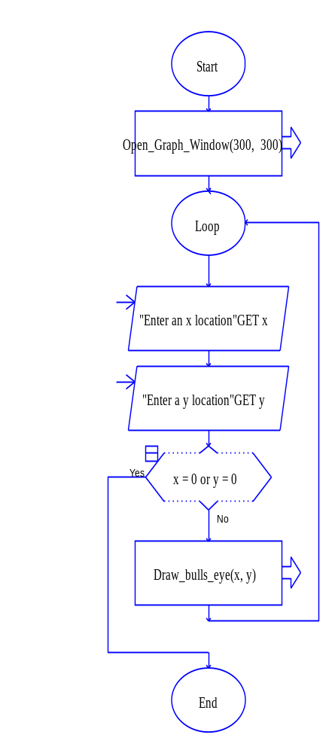

The major distinguishing feature of procedures is that each procedure has its own set of unique variables. If two procedures both contain a variable called X, then each procedure has a different memory location for its variable X. A change in the value of one procedure's X value will have no impact on the value of the other procedure's X variable. To illustrate this, consider the modified RAPTOR program to the right. This program gets an (x,y) location from the user to specify the position to draw a bulls-eye and then sends this location to the Draw_bulls_eye procedure. Now the main subchart has variables called X and Y and the Draw_bulls_eye procedure has variables called X and Y. If you recognize that these are separate variables, you will have no difficulties using procedures.

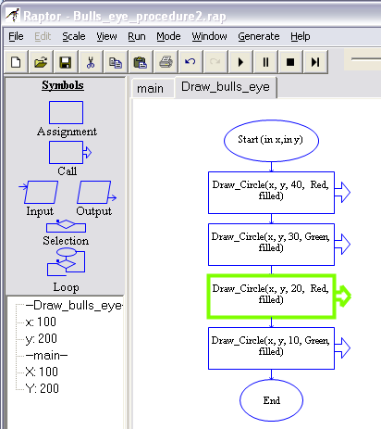
If you step through the execution of a program that contains procedures you will see new variables appear in the variable area of RAPTOR. These new variables will be listed under their procedure name. The computer does not have any difficulty associating variables with their appropriate procedure. Hopefully you won't either!

Procedure Parameters
Now that you have a good idea of how procedures work, we will explain the details of parameters. Remember that a parameter is simply a local variable of a procedure that has special properties.

There are three types of parameters:
- Input parameter - its value is initialized when the procedure is called.
- Output parameter - its final value is copied back to a variable in the calling sub-program.
- Input/Output parameter - its value is initialized when the procedure is called and its final value is copied back to a variable in the calling sub-program.
When you initially create a procedure you can specify the names of any parameters and their type. If you are unsure about what parameters you will need for a procedure when you initially create it, you can change the parameters at any time by right clicking on the procedure tab and selecting the “Modify procedure” option.

The typical scenario for any problem solving task goes something like this:
- Get some data.
- Use the data to calculate some “answers” to the problem.
- Send the “answers” back.
This sequence of tasks corresponds exactly to the input and output parameters of a procedure:
- To get initial data into a procedure, create appropriate input parameters.
- Use the parameter data (with possibly other calculated values) to calculate appropriate “answers”.
- Make sure that the variables that contain the “answers” are output parameters of the procedure.
To help make these ideas clear, please study the following example RAPTOR program.

Example Problem: Create a procedure that calculates the distance between two points.

Solution: Study the figures below that present a solution to this problem and notice the following:
- The “Distance” procedure has 4 input parameters, (x1,y1) and (x2, y2), all values of which are needed if the distance calculation is to be performed.
- The “Distance” procedure has 1 output parameter, length, which contains the “answer” to the problem.
- The “Distance” procedure has 2 local variables that are not parameters, dx and dy. A procedure can create and use as many variables as it needs to solve a problem, but these local variables only exist as long as the procedure is executing. The value of local variables is not remembered from one procedure execution to the next execution.
- Each of the example call statements (to the right) uses a different variable as the last parameter. This allows the procedure to be called multiple times and each call stores its “answer” in a separate variable.
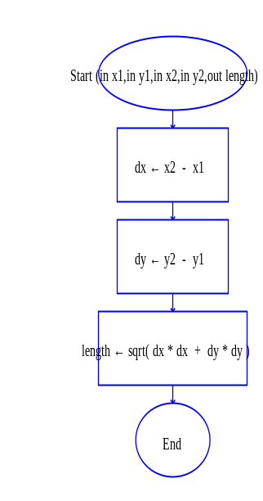
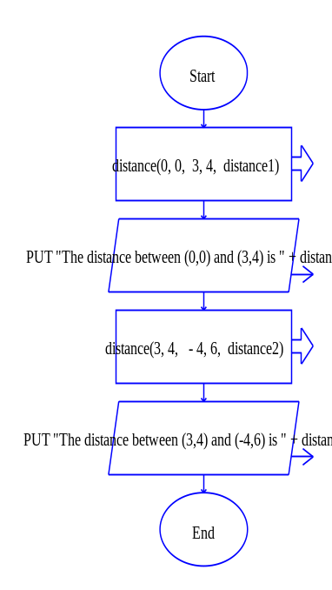
Distance Procedure
Parameter Definition
Example calls to the procedure

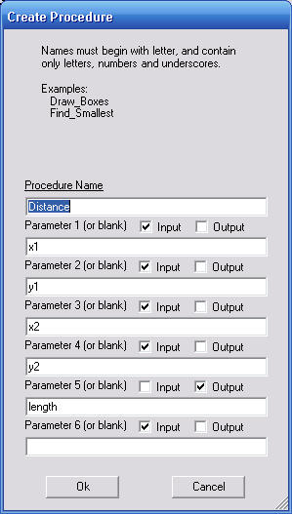

As stated previously, the order that parameters are listed in the procedure definition is very important. The same ordering that is used in the procedure definition must be used when a procedure is called. The ordering determines which values are associated with which parameters. You need to remember two simple rules for parameters when you call a procedure:
- If the procedure needs an input parameter, the call statement can use any expression that evaluates to an appropriate single value.
- If the procedure needs an output parameter, the call statement must use a single variable.
The following example calls to the previously defined “Distance” procedure will hopefully help you understand these rules.

Valid calls | Notes
Distance(0,0, 5,-3, answer)
Distance(x1,y1, x2,y2, dist1)
Distance(x+3, y-7, x*2+5, (y-3)*4, distance2)
Invalid calls
Distance(0,0, 5,-3, 4)  Distance(x1,y1, x2,y2, dist1+7) | The last parameter must be a single variable, since it is an output parameter.

Summary
In this reading we have covered how to solve complex problems by separating programming statements into distinct groups of commands called subcharts and procedures. You can use subcharts if your problem allows you to use the same variables throughout all your sub-programs. If you want to isolate variables to a specific set of statements so that they do not interact with other parts of your program, then you must use procedures. Simple programs can be written using subcharts, but more complex programs typically require the use of procedures.

What you have hopefully learned…
- If you are implementing programming statements that solve a non-trivial problem, it is beneficial to separate the statements into logical sub-programs.
- A subchart is a series of related programming statements that solve a small sub-problem of a larger problem.
- A subchart uses the same variables as all other subcharts. If two subcharts use a variable called X, they are using the same value.
- A procedure is a series of related programming statements that solve a small sub-problem of a larger problem.
- A procedure uses a distinct set of variables that is separate from all other sub-programs. If two different procedures use a variable called X, they are using different values.
- A parameter is a variable inside a procedure.
- Input parameters get initialized from values in a procedure call.
- The final value of an output parameter is set to its associated variable in the procedure call statement.

